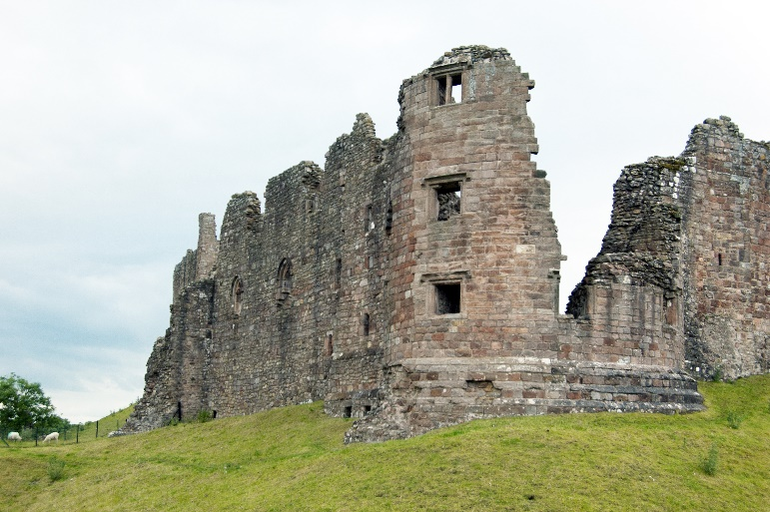
BROUGH CASTLE (Courtesy of JB Kerr)

One of the English countryside’s unspoilt gems, the Lune Valley begins just a few minutes’ drive from Lancaster and borders the Forest of Bowland, Area of Outstanding Natural Beauty, and the Yorkshire Dales. Picturesque villages with unique heritage and individual shops, cafes and pubs are dotted throughout the valley.

We intend to be visiting the following sites with other sites under consideration

Brough Castle and Church Sedbergh
Ravenstonedale Fairfield Mill Sedbergh
Kirkby Stephen Church and town Brigflatts Quaker Meeting House Sedbergh
Kirkby Lonsdale Sizergh Castle
Levens Hall and gardens Heron Corn Mill
Leighton Hall and Garden Morecambe
Heysham St Peter’s Church Lancaster Castle / Fort
Heysham St Patricks Chapel Gamelands Stone Circle
Glasson Old Port Lune Aqueduct

Accommodation and travel: We will be based at the Holiday Inn, Lancaster. Members are to make their own way to the hotel. Trains run directly from London Euston to Lancaster.

The cost: Prices include bed and breakfast, dinner, entrance fees and coach. Members must provide their own lunches but stops will be made to enable this. The meeting is open only to members. Members are advised to have travel insurance.

Single room: £800 per person
Twin/Double room: £600 per person (based on two people sharing)

Enquiries to: Caroline Raison, csraison@gmail.com ; Tel. 07801 352924

Please apply by 28th June to Caroline at csraison@gmail.com. The Administrator will then contact you with the Institute’s bank details. Members can pay in part or in full – with all the issues over covid, members should have travel insurance in case they need to cancel. If members wish to cancel for any reason, we shall refund as below:
- Costs can be refunded up to 91 days prior to arrival
- Between 90 and 60 days 25% cancellation fee on the hotel cost
- Between 59 and 46 days 50% cancellation fee on the hotel cost
- Between 45 and 29 days 75% cancellation fee on the hotel cost
- Less than 28 days 100% cancellation fee for the hotel and other costs

Booking Form

Member name(s)…………………………………………………………................................
Address…………………………………………………………………………………………
…………………………………………………………………………………………………..
Email…………………………………………………………………………………………....
Telephone………………………………………………………………………………………
Special dietary requirement…………………………………………………………………...

I/We require ……... Single room(s) at a cost of £800 per person.

I/We require ……... Twin/Double room(s) at a cost of £600 per person. Sharing with…………………………………………………………….

Payment: Preferably by bank transfer. However, if paying by cheque, cheques should be made payable to ‘Royal Archaeological Institute’.

The booking form/payment should be returned to:

Caroline Raison
RAI Assistant Meetings Secretary
48 Park Avenue
Princes Avenue
Kingston upon Hull
HU5 3ES

